Accelerated Thread

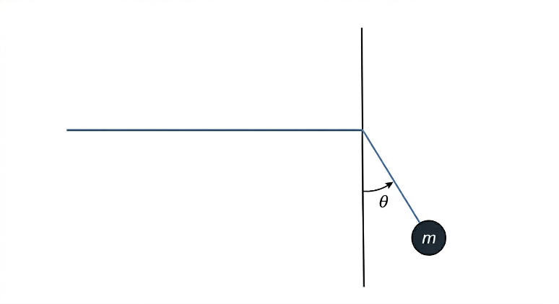
A small ball of mass m is hanging from a thread as shown in the figure. It is initially at rest at an angle θ from the downward vertical and released from that position and t = 0. The thread is constantly being pulled by a person running with an acceleration of a m/s² also starting from rest at t = 0.

Find the direction in which the ball initially starts to move at t = 0.

